PCH (Platform Controller Hub) ke Important Sections
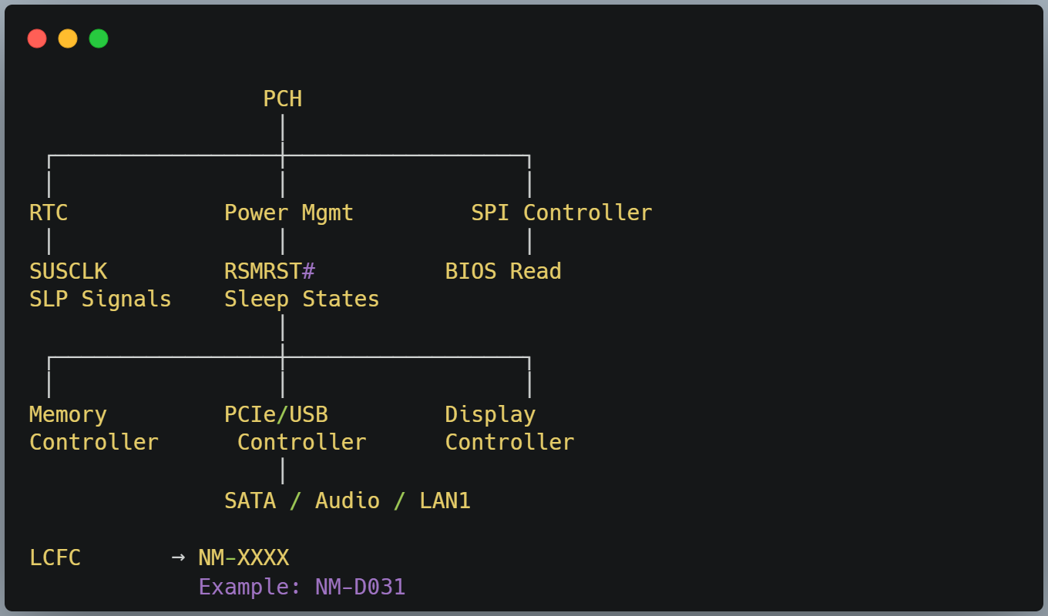

1. RTC Section ⭐⭐⭐
Kaam
- RTC Battery (VBAT)
- Date & Time
- CMOS Settings
- 32.768 KHz Crystal
- SUSCLK Generate
Repairing
Check:
- RTC Voltage
- RTC Crystal
- SUSCLK

2. Power Management Section ⭐⭐⭐⭐⭐
Ye sabse important section hai.
Kaam
- RSMRST#
- SLP_S5#
- SLP_S4#
- SLP_S3#
- PM_SLP_S0_N
- PWRGOOD Monitor
- VR_ON
Ye pura Power Sequence control karta hai.

3. SPI Controller ⭐⭐⭐⭐
Kaam
BIOS Read karta hai.
PCH
│
SPI
│
BIOS
Repairing me
Agar BIOS Communication nahi hai
to laptop ON nahi hoga.

4. Memory Controller Interface ⭐⭐⭐⭐
Intel ke naye processors me actual Memory Controller CPU ke andar hota hai, lekin PCH memory initialization aur coordination me role play karta hai.
Related Signals
- DDR_EN
- Memory Reset
- Memory Detect

5. PCIe Controller
Kaam
- WiFi
- LAN
- NVMe SSD
- GPU

6. USB Controller
Kaam
- USB Ports
- Keyboard
- Mouse
- Pendrive

7. SATA Controller
Kaam
- HDD
- SSD

8. Audio Controller
Kaam
Audio Codec se communication.

9. LPC / eSPI Interface ⭐⭐⭐⭐
Ye bahut important hai.
PCH
│
eSPI/LPC
│
EC(SIO)
Isi interface se
EC aur PCH communication karte hain.

10. Reset Section ⭐⭐⭐⭐
Is section se
- RSMRST#
- PLTRST#
- DRAMRST#
Generate hote hain.

11. Clock Section ⭐⭐⭐⭐
Isme
- RTC Oscillator
- SUSCLK
- Clock Distribution
Hota hai.

12. Thermal Management
Temperature monitor karta hai.

📌 Motherboard Repairing Rule
Repairing ke liye PCH ko in 4 major blocks me yaad rakhiye:
- RTC Block → RTC Voltage, Crystal, SUSCLK
- Power Management Block → RSMRST#, SLP_S5#, SLP_S4#, SLP_S3#, PM_SLP_S0_N
- SPI Block → BIOS Read
- Communication Block (eSPI/LPC) → EC ↔ PCH Communication
Agar ye 4 blocks ka sequence samajh aa gaya, to aap Intel laptop motherboard ke power sequence aur no-power troubleshooting ka major hissa aasani se diagnose kar sakenge.

